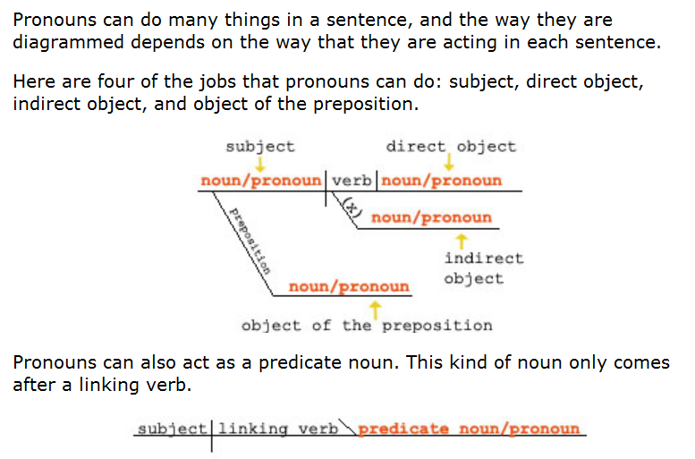

_____________________________________________________________________

http://www.english-grammar-revolution.com/list-of-pronouns.html

______________________________________________________________________________
http://esl.about.com/od/beginningenglish/ig/Basic-English/Pronouns.htm

There are four types of pronouns: Subject Pronouns, Object Pronouns, Possessive Pronouns and Demonstrative Pronouns. Here is a list and explanation showing the different types of pronouns:
- Subject Pronouns - I, you, he, she, it, we, you, they function as the subject of a sentence:
I live in New York.
Do you like playing tennis?
He doesn't want to come this evening.
She works in London.
It won't be easy.
We are studying pronouns at the moment.
You went to Paris last year, didn't you?
They bought a new car last month.
- Object Pronouns - me, you, him, her, it, us, you, them serve as the object of a verb.
Give me the book.
He told you to come tonight.
She asked him to help.
They visited her when they came to New York.
She bought it at the store.
He picked us up at the airport.
The teacher asked you to finish your homework.
I invited them to a party.
- Possessive Pronouns - mine, yours, his, hers, its, ours, yours, theirs show that something belongs to someone. That house is mine.
This is yours.
I'm sorry, that's his.
Those books are hers.
Those students are ours.
Look over there, those seats are yours.
Theirs will be green.
- Demonstrative Pronouns - this, that, these, those refer to things. 'this' and 'these' refer to something that is near. 'that' and 'those' refer to things that are farther away.
This is my house.
That is our car over there.
These are my colleagues in this room.
Those are beautiful flowers in the next field.
- Possessive adjectives - my, your, his, her, its, our, your, their are often confused with possessive pronouns. The possessive adjective modifies the noun following it in order to show possession.
I'll get my books.
Is that your car over there?
That is his teacher, Mr Jones.
I want to go to her store.
Its color is red.
Can we bring our children?
You are welcome to invite your husbands.

